**pBrooklyn torah gazette**

**For parshas shemos 5781**

Volume 5, Issue 19 (Whole Number 219) 25 Tevet 5781/ January 9, 2021

**Printed L’illuy nishmas Nechama bas R’ Noach, a”h**

For a free subscription, please forward your request to [***keren18@juno.com***](mailto:keren18@juno.com)

Past emails can be found on the website **ShabbosStories.com**

**The Danger of Making Assumptions From**

**Jewish Story Books**

**By Daniel Keren**



**Rabbi Eli Reisman**

The third speaker at last month’s December 25th Legal Holiday Hakhel Yarchei Kallah Event was Rabbi Eli Reisman, Chaver of the Edison Community Kollel. The topic of his fascinating lecture was “What Happens When You Pasken from Story Books and the Internet.”

He began with an amusing account of the story that everyone forgot. One of the grandchildren of the famed Baal Shem Tov, founder of the Chassidic movement lived anonymously and spent most of his time learning Torah li’shmo. As such he lived in extreme poverty. One Erev Shabbos, his plight became too much for him to continue to bear.

He bitterly cried out in the shul when many people had come to daven about this injustice – “How was it possible that an einikel of the Baal Shem Tov should be allowed to have nothing to eat and suffer?”

People in the shul were startled and they agreed that this was a terrible travesty. Some declared that they should right then and there make an appeal on behalf of this grandchild of the holy Baal Shem Tov. And many generous pledges were made. All of a sudden, the einekel had regrets, thinking to himself how could he abuse his yichus in such a cavalier manner. He then and there prayed to Hashem that all those who made pledges should forget their commitment. And indeed not one person followed through with their promise.

So the question remains how if everyone forgot their pledge, the story was told. Certainly the grandson didn’t write down the story as he was embarrassed by having cried out in the first place for help from a basar v’dam (human beings made of flesh and blood) instead of having requested help from Hashem. Rabbi Reisman explained that perhaps there was someone in the shul hiding behind the furnace who himself did not make a pledge but remembered what happened and told or wrote down the story for posterity.

**The Story about the Sukkah of “All for the Boss”**

Another story that has been told is about Reb Yaakov Yosef Herman, the hero of Ruchama Shain’s “All for the Boss.” The story relates how for one Sukkos Mr. Herman who lived in the Lower East Side of Manhattan where space for building sukkos (temporary dwellings) was almost non-existent, solved his problem, by building his sukkah on the roof of the tenement apartment building he lived in.

According to one opinion he was hauled to court on the first day of Chol Hamoed by his landlord who argued that he had no right to build a sukkah on his roof as it was the landlord’s property. The judge agreed with the landlord and then decreed that Mr. Herman had eight days to take down his “temporary” dwelling, to which Mr. Herman happily promised to be in compliance within the time limit imposed by the court.

Rabbi Reisman says this brings up a problem. How could we assume that Mr. Herman would in the first place construct his sukkah without first getting permission from the landlord. Therefore assuming that he did indeed get permission from the landlord, it was most probably a fire inspector who cited Mr. Herman and hauled him in to court, at which point Mr. Herman was not violating the property rights of his landlord and was joyful to agree to have his sukkah dismantled no later than eight days after the first day of Chol Hamoed.

Another story that Rabbi Reisman said proves one must be careful to not posken from is the classic account of how during a terrible cholera epidemic that was ravaging Vilna in 5610/1849, the famed founder of the Mussar movement – Rabbi Yisroel Salanter has arranged for posters to be placed throughout town commanding the Yidden to not fast on the holiest day of the year and to rather eat in order to preserve their health.

**Making Kiddush on the Bimah of the Main Synagogue on Yom Kippur**

On the day of Yom Kippur he ascended the bimah of the main synagogue in Vilna and holding in one hand a plate of cake and in another hand a cup of wine, proceeded to make Kiddush. He then drank from the wine and ate some of the cake and told everyone in the shul to go home and do the same.

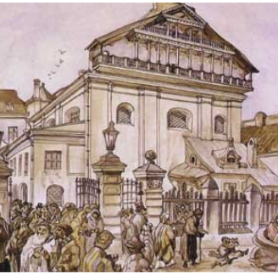

**Watercolor of the Great Vilna Synagogue by Juozas Kamarauskas (1899)**

One might pasken that if one is ill on Yom Kippur, one should follow in the famous manner of Rabbi Salanter. Yet, Rabbi Reisman pointed out that there is an opinion that if one has to eat on Yom Kippur because one is ill, one doesn’t make Kiddush. So how do we reconcile this with the many stories told over the last century and a half of just how Rabbi Salanter did indeed make a Kiddush in the most important shul in Vilna in order to emphasize the importance of not fasting on that Yom Kippur because of the great danger of the cholera epidemic that was killing thousands of Jews throughout that part of Europe?

Interestingly, Rabbi Reisman noted that that year was one in which Yom Kippur fell on Shabbos and on Shabbos one is obligated to make Kiddush. So the Kiddush that Rabbi Salanter made that year was not a contradiction to the opinion that an ill person doesn’t make Kiddush on Yom Kippur, but a fulfillment of the obligation a Jew has to make Kiddush on Shabbos.

Those unable to attend last week’s Hakhel Event can call Mr. Zalman Umlas at (718) 252-5274 to purchase CDs and downloads.

*Reprinted from the December 31, 2020 edition of the Flatbush Jewish Journal.*

# Rav Avigdor Miller

# On Gender Roles

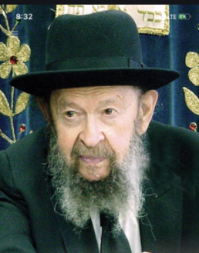

**QUESTION:** **Why is it that Hashem is referred to as “He” or “Him”? Why don’t we say “She” or “Her”?**

**ANSWER:** Because we’re not completely meshuga yet. We didn’t get there just yet.

Look; here’s a man and he has a beard. A woman has no beard, right? You’ve see many women in your life and you’re yet to see a woman with a beard. And a man is taller than a woman. A woman is the shorter of the two. That’s how Hashem made this world; the man is the more powerful. He’s stronger, bigger, and he instills more fear.

So, if you’re going to choose a model, a model for one who’s in charge of the world, are you going to choose the model of a soft, sweet woman?! Isn’t that being ridiculous?!

And that’s why we have a government today that takes our money to pay women to be policewoman. Because people are stupid. People are ridiculous. I’m walking down Kings Highway, and here’s a policeman, six feet high, and standing next to him is a policewoman who is up to his belly-button! It’s a joke, a waste of our money. It’s just liberal window-dressing that costs us money for nothing.

The whole idea of elevating women to places of power, is nothing but the insanity of the liberals. Women are dignified and are to be honored and the Jewish women are a treasure; they are the foundation of our nation. But do they represent strength and power and control? Does the woman signify might?! And therefore, there is no question that when you speak of Hakodosh Boruch Hu, we speak of Him as a man.

*Reprinted from the December 30, 3030 email of Toras Avigdor. - TAPE # 990 (December 1994)*

**Thoughts that Count**

**For Parshat Shemos**

*And behold, it was a weeping boy... and she said, This is one of the Hebrews' children* (Gen. 2:6)

How could Pharaoh's daughter have recognized that the child was Jewish, just from his cry? This is because a Jewish cry is unique; a Jew, even when he weeps, is filled with hope. *(Rabbi Mordechai Chaim of Slonim)*

And she called his name Moses... because out of the water have I drawn him (Gen. 2:10)

**The Responsibility of a Jewish Leader**

The name Moses ("Moshe" in Hebrew) comes from the verb "to draw out," and is in the present tense, indicating an ongoing action.

This alludes to the task of the true Jewish leader, which is to elevate the Jew from the depths of physicality and guide him toward the shores of spiritual safety. Moses, the first Jewish leader, was the prototype for all time; his actions are continued by the "reflection of Moses" that exists in every generation. *(Teivot Shalom)*

**The Tree of the Field**

*And an angel of G-d appeared to him in a flame of fire from the midst of the thorn bush; and he looked, and behold, the thorn bush was burning with fire, but the thorn bush was not consumed* (Exodus 3:2)

Man is likened to a tree of the field: the Torah Sage is a fruit- bearing tree, whereas the simple Jew is likened to a tree that does not give fruit.

Nonetheless, the "flame of fire" burns precisely in the humble "thorn bush" -- in the simple and unlearned Jew.

A Jew who prays and recites Psalms with simple faith in G-d possesses a fire of holiness derived from purity of heart, even if he does not understand the words.

Furthermore, the "thorn bush is not consumed." The burning flame of the simple Jew can never be extinguished, as he is perpetually thirsty for Torah and mitzvot -- unlike his more learned counterpart, who is able to quench his thirst with the waters of Torah. *(The Baal Shem Tov)*

**The Responsibility in**

**One’s G-dly Service**

*Let the work be made to lie heavily upon the men, that they labor in it, and that they may not pay attention to false words* (Exodus 5:9)

A true Chasid knows that his service of G-d requires great personal effort and exertion. Thus he will never ask his Rebbe for a blessing to attain that which he is obligated to accomplish on his own...*(The Tzemach Tzedek)*

*Reprinted from the Parshat Vayechi 5756 edition of the L’Chaim Weekly, a publication of the Lubavitch Youth Organization.*

**Rabbi Berel Wein on**

**Parshat Shemos 5781**



It is difficult to imagine a more unlikely scenario than the one described for us in the Torah as to the process of redemption of the Jewish people from Egyptian slavery. We can readily understand a personality of holiness and tranquility such as Aaron becoming the hero and redeemer of the holy people of Israel. We could also easily understand that the redemption could come from negotiations and the recognition by Pharaoh and the Egyptians that it was in their best interests to allow the Jewish people who escaped from slavery. Yet, that certainly is not the way the Torah presents this story for us.

Instead, the redeemer is an unlikely figure, not even part of the Jewish story for approximately half of his lifetime. Not only that, he risked his life on behalf of the Jewish people but, in fact, was betrayed by Jews themselves. And he is a reluctant Redeemer, telling the L-rd, so to speak, to find someone else to do the job for he feels that he is not capable to fulfill the task at hand.

**All of Moshe’s Excuses are Rejected**

Heaven disregards all his complaints and accepts none of his excuses. Heaven is aware of all human shortcomings and assigns great tasks for individuals to fulfill irrespective of the inadequacies that they may feel.

Moshe is the most humble and modest of all human-beings, but he is not allowed to be humble and self-effacing at this moment. We see him in his most aggressive and assertive mode when speaking to the Pharaoh. For when it comes to the time to redeem the Jewish people, he cannot be fainthearted, passive, or subservient any longer.

**The Current Revival of Torah Values**

**Have Occurred in a Most Unusual Fashion**

In our time over the past century the redemption of Israel, the ingathering of the exiles to our ancient homeland, the establishment of the state of Israel and the revival of Torah values and study in the Jewish world all have occurred in a most unusual fashion. The logical odds against it happening were and are enormous but nevertheless it has happened and in front of our very eyes. Perhaps we would have chosen to have different leaders in a different series of events and policies that could have brought all this about. But it is well known that Heaven mocks all our pretensions and predictions.

**Experiencing Jewish Life is**

**Not for the Faint Hearted**

The prophets of Israel have clearly told us that our redemption is a certainty and will occur. How this will happen was never spelled out for us in detail. The Jewish people will be rebuilt in our ancient homeland of the land of Israel and we see that this is happening in our days. We are taught that the wonders that we shall see and experience in this final redemption will outdo even the wonders and miracles that marked our exodus from Egypt under the leadership of Moshe over three millennia ago. Experiencing Jewish life is not for the faint hearted nor the doubters nor the weak willed. This is only one of the many insights and lessons that we can derive from the Torah reading of Shemot.

*Reprinted from the Parshat Shemos 5756 edition of the L’Chaim Weekly, a publication of the Lubavitch Youth Organization.*

**Why G-d Required the Jews**

**To be Enslaved in Egypt**

**From the Talks of the Lubavitcher Rebbe**

**Rabbi Menachem Mendel Schneerson, Zt”l**

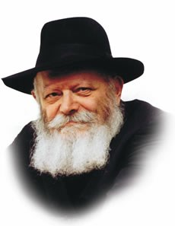

"I will give this people favor in the eyes of the Egyptians, and when you depart, you will not go empty," G-d tells Moses in our Torah portion, Shemot.

According to the Midrash, G-d promised that the Egyptians would willingly pay the departing Jews with gifts of gold and silver "so that Abraham would not be able to claim that G-d had fulfilled the first part of the covenant -- `and they will be enslaved and tortured' -- but not the second part -- `and afterward they will leave with great wealth.'"

**G-d Fulfills His Promises All the Time**

This explanation, however, is insufficient. How could this be the only reason G-d fulfilled His promise? Doesn't G-d fulfill His promises all the time, as it states, "For G-d is not a man who tells falsehoods"?

To explain:

The huge amount of gold and silver that was given to the Jews just prior to the Exodus served a dual purpose: to punish the Egyptians for their cruelty, and to reward the Jews for their 210 years of suffering. But which one of these was the primary purpose -- reward or punishment?

Was the benefit derived by the Jewish people secondary to the main objective of punishing the Egyptians, or was their enrichment the primary goal, and the loss it represented to the Egyptians only secondary?

**The Demand of the Egyptians During**

**The Time of Alexander the Great**

The Talmud relates that in the time of Alexander the Great, the Egyptians demanded that the Jews return the riches they had acquired generations before.

The response of Geviha ben Pesisa, the leader of the Jews, was that the gold and silver rightfully belonged to the Jews as "the wages of the six hundred thousand whom you enslaved in Egypt."

This answer provides us insight into why it was necessary that the Jews "find favor in the eyes of the Egyptians," and why Abraham's potential claim had to be refuted:

For there to be the fullest measure of justice, G-d wanted the Jewish people to be rewarded in the same open manner as Abraham's service was conducted in the world.

Just as all mankind was witness to the Jewish people's enslavement, so too was it necessary for the entire world to see the Egyptians making reparations of their own free will.

**The Inner Meaning of the “Great Wealth”**

Chasidic philosophy explains that the inner meaning of the "great wealth" that was taken by the Jews consisted of the "sparks of G-dliness" that were hidden in Egypt. The service of the Jewish people enabled these sparks to be redeemed and restored to their G-dly source above.

Nonetheless, the primary objective of the entire experience in Egypt was the betterment of the Jews themselves, whereas the elevation of the sparks was only secondary. For the inner purpose of the exile was the spiritual elevation that was achieved thereby, the main reason for the Jews' going into exile in the first place.

*Adapted from Likutei Sichot of the Rebbe, Vol. 21*

*Reprinted from the Parshat Vayechi 5756 edition of the L’Chaim Weekly, a publication of the Lubavitch Youth Organization. Adapted from Sefer HaSichot of the Rebbe, Vol.21.*

**The True Litmus**

**Test of Our Spirituality**

**By Rabbi Moshe Meir Weiss**

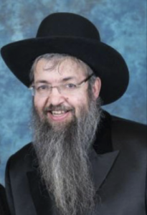

At the end of Yakov Avinu’s life, he revealed to Yosef, “Re’o fonecha lo filalti, v’hinei her’ah osi Elokim gam es zarecha – To see your face I had not prayed, and behold Hashem has allowed me to even see your children.” On the simple level, this means that Yakov was expressing that he never prayed even once to again meet-up with Yosef. This was because he was told by his sons that Yosef was torn asunder and one is not allowed to pray a tefilas shav, a meaningless prayer to Hashem.

**The Significance of the Words “Your Face”**

The Toldos Chaim digs deeper into the meaning of this posuk. He asks, Why does it say “Re’o fonecha lo filalti – To see your face I did not pray?” Would it not have sufficed to say, “Re’oscha lo filalti – To see you I did not pray?” Why the addition of fonecha, your face?

He explains that Yakov reasoned to himself that even if by some miracle Yosef had in fact survived, after all of this time – growing up in a foreign culture – it is likely that he would have assimilated and fonecha, his penimius, his spirituality would likely have been destroyed.

But now, Yaakov continued, Hashem showed me your fine children, Efraim and Menasha, who are also walking in the ways of true Yiddishkeit, and there is no better proof of the inner makings of a person than how their children turn out. Concludes the Toldos Chaim, if a person practices superficial Judaism – only doing the rituals to be accepted by others or because they have to, that kind of robotic Yiddishkeit doesn’t pass very successfully to the next generation.

In this vein, Reb Yitzchak Elchanan Spektor, zt”l, zy”a, the famed Kovno Rav, explains the verse from our Shabbos maariv liturgy, “V’shamru B’nei Yisroel es haShabbos, la’asos es haShabbos l’dorosom – The Bnei Yisroel should keep the Shabbos, to make the Shabbos for their generations.”

**Making Shabbos Full of Warmth**

**To Inspire Your Children**

The Rav questions why it repeats itself, “To keep the Shabbos, to make the Shabbos.” He observes that the posuk is informing us what kind of Shabbos we should keep. A Shabbos that will ensure that the Shabbos will stay with your generations. Shabbos should be so full of warmth and inspiration that your children should feel that they can’t do without it.

I believe that this is also a homiletic understanding of the Talmudic dictum in the second perek of Masechtas Shabbos. “Haragil b’ner havyon, lo banim talmidim chachamim – If someone is careful with the candles (of Shabbos and Chanukah), they will have children who are Torah sages.”

**One’s Judaism Should be Full of Passion**

This can be explained as follows. If someone’s Judaism is full of a fire, is done with hislahavus, with a passion, then they will have children who are Torah scholars. On the other hand, one whose ritualistic practices are lackluster, robotic and passionless, will not inculcate a deep sense of feeling into their descendants.

The Vishnitzer Rebbe, zt”l, zy”a, once told a chosid who had sent his children to the gymnasium in pre-war Europe, “During the winter when the trees are barren, only a dendrologist (a specialist in the study of trees) would know what type of tree it is. But, when the spring comes and they see the fruit, everyone knows whether it’s an apple or pear tree. So too, the character of a person can be discerned from their fruits.” The man took the subtle hint and removed his children from the gymnasium.

May it be the will of Hashem that we serve Hashem with passion and gusto, and in that merit may we be blessed with long life, good health and happiness to see many generations of Torah success.

*Reprinted from the December 29, 2020 email of The JEWISH VUES.*

**Parshas Shemos**

**The Difference Between Emunah and Bitachon**

**By Rabbi Bentzion Shafier**

**Founder of TheSmuz.com**

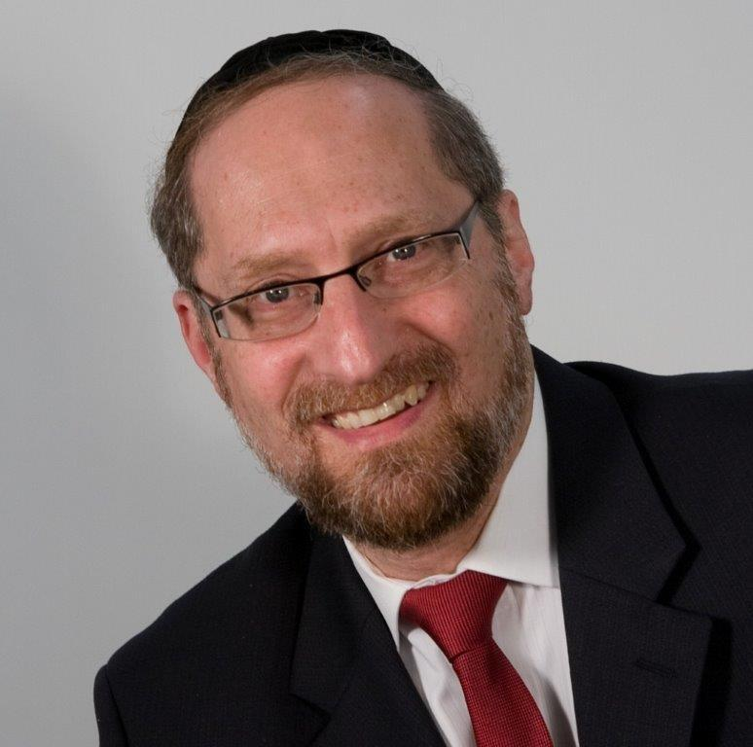

“*And Moshe returned to HASHEM and said,* ***“****HASHEM, why have You done evil to this people? Why have You sent me?”* — Shemos 5:22

HASHEM sent Moshe Rabbeinu to be the redeemer of the Jewish people. However, from the moment that he embarked on this mission, the slavery became more intense and the pain more profound. Out of love for his nation, Moshe turned to HASHEM and said, “Why have You worsened the situation? Why have You sent me?”

The Gemara tells us that Moshe was punished for questioning HASHEM. HASHEM said, “It is a shame that that which is lost can no longer be found.” It is as if HASHEM were saying, “They don’t make them like they used to. Avrohom, Yitzchak, Yaakov, those were great people, but no more. Moshe, you don’t compare to them. They trusted Me, but you aren’t on their level.”

**Moshe was the Single Greatest**

**Human Being who Ever Lived**

The question on this Gemara is that that the single greatest human being who ever lived was Moshe Rabbenu. The Rambam calls him the “father” in Torah and wisdom. He was the greatest of all prophets. In fact, one of our Thirteen Principles of Faith is that Moshe was the greatest of all Navi’im, greater than those who came before him and those who came after.

Since we know that Moshe was greater than even the Avos, how can we understand this Gemara? It seems to saying that Avrohom, Yitzchak, and Yaakov were superior to Moshe.

**The Difference Between**

**Emunah and Bitachon**

The answer to this question lies in understanding the distinction between emunah and bitachon. The Rambam defines emunah as the knowledge that HASHEM **created** and **continues to run** all of Creation. Simply put, nothing can exist and no activity can occur without HASHEM.

Bitachon, however, is a quite different. The Chovos Halevovos defines bitachon as **trusting** in HASHEM. It is a sense of relying on HASHEM to watch over and protect me, as if to say, “I take my heavy burden and place it on HASHEM.” While I am responsible to be proactive, I am not in charge of the outcome, and I am not the determinant of the results. I rely on HASHEM to care for me.

Emunah is a state of **understanding**; bitachon is a state of **trust**. Emunah means **knowing** that HASHEM is involved in every activity on the planet; bitachon means **trusting** in HASHEM in every situation.

**A Person Can Have Emunah**

**And Not Bitachon**

A person can have emunah and not bitachon. Pharaoh was a classic example. When threatened by the Jewish overpopulation, Pharaoh’s solution was to throw the baby boys into the Nile. The Medrash explains that this wasn’t a flippant reaction – it was highly calculated. Pharaoh knew that HASHEM promised Noach that He wouldn’t bring another flood.

He also knew that HASHEM pays back “measure for measure.” Therefore, Pharaoh determined that HASHEM would want to bring a flood to pay back the Egyptians for drowning the babies, but because of HASHEM’s promise to Noach, that couldn’t happen, so he felt protected from HASHEM’s wrath.

Clearly, Pharaoh understood the power of HASHEM. He realized that HASHEM watches over the world. He also understood that HASHEM acts with justice. Pharaoh had no problem with emunah, but he sure didn’t trust in HASHEM – he rebelled. He had emunah, but no bitachon.

**Growing in Emunah**

Both emunah and bitachon are based on relating to the world in a deeper manner. Emunah is the understanding that HASHEM is involved in more than just the big picture issues: life and death, war, famine, disease. . . HASHEM is involved in the minutiae of my daily life. HASHEM is there with me, 24/7, 365, all day, every day, from morning to night.

Amazingly, I can have this understanding and yet lack a level of trust in HASHEM.

Bitachon requires understanding the goodness of HASHEM

To truly rely on HASHEM, there are two additional criteria I must feel. I must know that HASHEM loves me more than I love myself, and I must know that HASHEM knows better than I do what is for my good.

Bitachon is predicated upon knowing that HASHEM has my best interests in mind and that He knows better than I what is for my good. When a person realizes this, and then takes his heavy load and transfers it to HASHEM – that is bitachon.

The answer: Moshe was greater in emunah – the Avos were greater in bitachon

The answer to the question seems to be that Moshe Rabbeinu was on a higher level of emunah than any other human being, then or since. He saw HASHEM with an absolute clarity. Just as we see a piece of wood in front of us as undeniably real, he saw HASHEM – right there. But absolute trust in HASHEM doesn’t necessarily follow.

**Bitachon is Learned and Practices**

Bitachon is learned, and practiced. Much like a character trait that one develops over many years, one learns, often through life experiences, to be totally and utterly trusting in the kindness of HASHEM. Apparently, the Avos reached a higher level in this regard. They had an unwavering sense of the constant goodness and loving kindness of HASHEM; hence, they were able to be more trusting of HASHEM even when on the surface, there were many questions to be asked. Moshe was greater in emunah, while they were greater in bitachon.

This distinction has great relevance. Often our problems with faith come from this one issue: we have emunah, but not bitachon. When a person comes to the core understanding that HASHEM is more concerned for my good than I am, and that HASHEM knows my needs far better than I, he comes to a different degree of trust, a different level of relying on HASHEM. He comes to true bitachon.

*Reprinted from the website of Theshmuz.com.*

**Halacha:**

**Allowing a Doorman to Open An Electric Door When One Enters a Building on Shabbat**

**By Rabbi Eli Mansour**



In many apartment buildings today, a power-operated door is used in the main entrance. A doorman stands by the entrance and presses a button that electronically opens the door when a resident or guest arrives.

The question naturally arises as to whether a Jew may enter such a building on Shabbat. Halacha forbids allowing a gentile to perform Melacha (an act forbidden on Shabbat) on one’s behalf on Shabbat. Seemingly, then, it would be forbidden for a Jew to allow a doorman to press the button to open the door for him when he arrives at the building on Shabbat.

**The Doorman Could Open the Door Manually**

In truth, however, Rav Shemuel Pinhasi (contemporary scholar in Israel), in his work Ve’daber Davar (4:10), rules that one may allow a doorman to activate the electric door on Shabbat. Since the possibility exists of opening the door manually, by turning the handle, we do not consider the gentile as performing Melacha on behalf of the Jew. The doorman chooses to open the door electronically for his own convenience, and not because the Jew specifically wishes that the door be opened in this fashion. As such, the gentile acts in his own interest, rather than in the Jew’s, and the Jew may therefore allow him to open the door electronically. The Jew may not, however, explicitly request that the doorman open the door for him on Shabbat. He may make such a request only indirectly, such as by saying, “The door is locked” or “I would like to come inside.”

**SUMMARY:** One may allow a gentile doorman to open a power-operated door on his behalf on Shabbat. It is forbidden, however, to explicitly request that he open the door; one must express this request indirectly, such as by saying, “The door is locked.”

*Reprinted from the Parashat Vayechi 5781 email of iTorah.com*

**What Does the Jewish Last Name Shapiro Mean?**

**By**[**Menachem Posner**](https://www.chabad.org/search/keyword_cdo/kid/12145/jewish/Posner-Menachem.htm)

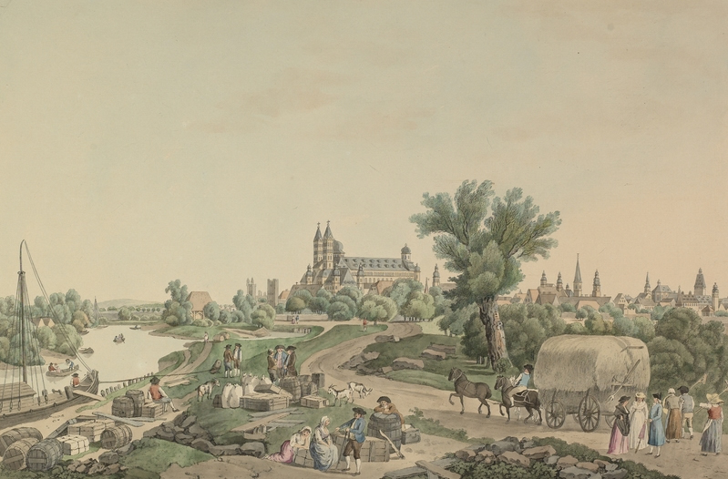

**An old painting depicting the German city of Speyer.**

Often spelled Shapiro, Schapiro and Spiro, the version of this name that is actually most accurate is probably Shapira. They are all iterations of Shpira (שפירא), the Jewish name for the German city of Speyer (once known as Spira), which has a long and tragic Jewish history.

Along with Mainz and Worms, it formed the cradle of Ashkenazi culture, and the first records of Jews in Speyer date back to the 10th century. The three cities were collectively known as ShUM, an acronym for Shpira (Speyer), Vermaisa (Worms) and Magentza (Maintz).

Unfortunately, along with virtually every Jewish community in Europe, the Jews of Speyer suffered more than their fair share of bloodshed and persecution at the hands of their Christian neighbors, often at the urging of church officials.

While Jews were granted certain basic privileges in 1084 by officials who were eager for them to put their business acumen to work for the good of the region, it did not take long for the hatred to bubble over.

In 1096, they were among the first victims of the frenzied mobs of the First Crusade, and throughout the centuries, they continued to be the victims of successive waves of crusades and blood libels.

Even in the darkest times, Torah study flourished in the city, which produced several Torah scholars, many of whom were members of the prestigious Kalonymos family, which originated in Italy but had migrated to the Rhineland.

In 1349, the Jewish community of Speyer was totally wiped out by a bloodthirsty mob. Although Jews trickled back, it never regained its prominence. Indeed, Jews were banished from the city at various times, and at points were faced with the grim choice between forced baptism and death.

But though Jewish life ceased to exist within the city of Speyer, the noble heritage of its Jewish denizens lives on in the Torah scholarship they produced and in the many Jewish families that proudly bear its name.

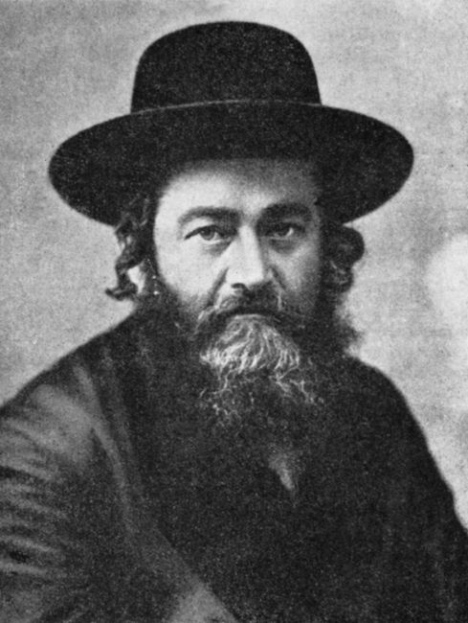

**Rabbi Meir Shapiro of Lublin (1887-1933)**

This very large family tree includes Rabbi Nathan Schapiro, who lived in Grodno and passed away in 1577; his grandson, also named Rabbi Nathan Schapiro, who was the rabbi of Krakow and author the Megaleh Amukot, and passed away in 1633; Rabbi Pinchas of Koretz, an early chassidic leader; his grandsons, the famous Schapiro brothers of Slavita; and Rabbi Meir Schapiro, chassidic leader and Torah scholar in Lublin, Poland.

*Reprinted from the Parshat Shemos 5781 email of Chabad.Org Magazine*